Travel with Purpose
Verification on how our tours are helping the planet.

1. The "Follow Your Dollar" Interactive Map
Travelers want to know their money isn't being lost in administration. A visual flow-chart shows how the $50 Conservation Fee included in a tour is "tokenized." See the exact moment your contribution reaches the anti-poaching unit in the Serengeti. Our blockchain ledger provides 100% transparency, eliminating the 'black box' of traditional donations.
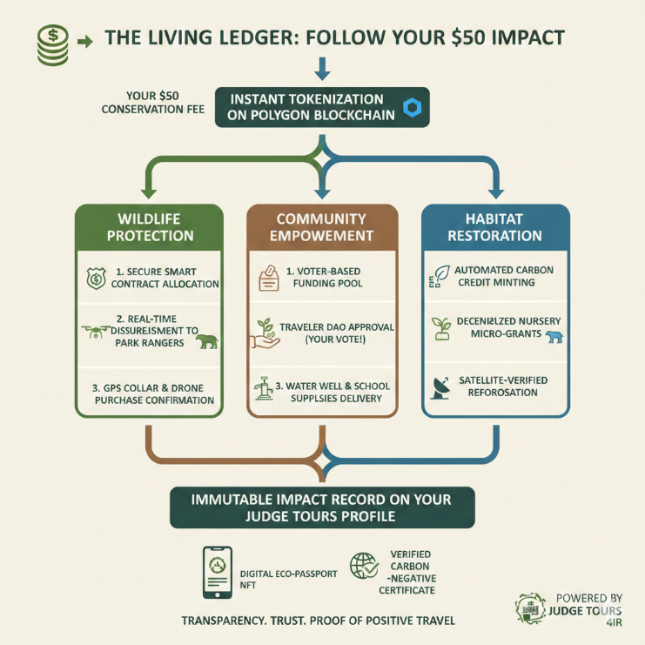

2. Digital Collectibles as "Eco-Passports" (NFTs)
Instead of a paper receipt, you will receive a digital trophy of your journey.
- Upon completing a tour (e.g., a "Silverback Guardian" token for Rwanda trekkers) you will receive impact tokens. Judge Tours handles the "gas fees”. Your tokens are securely tied to your Judge Tours account accessible via email yet protected by the blockchain.
- Your memories are now immutable. Receive a unique digital collectible that serves as a permanent, shareable record of the specific conservation projects you supported during your trek."

3. Real-Time "Biodata" Dashboard
Link the digital world to physical animals.
- IoT (Internet of Things) integration. Sensors in the parks feed data directly to the Web3 platform.
- Access live data from the field. Our Web3 portal allows you to see reforestation growth rates or wildlife migration patterns protected by your visit, verified by satellite and ground sensors.
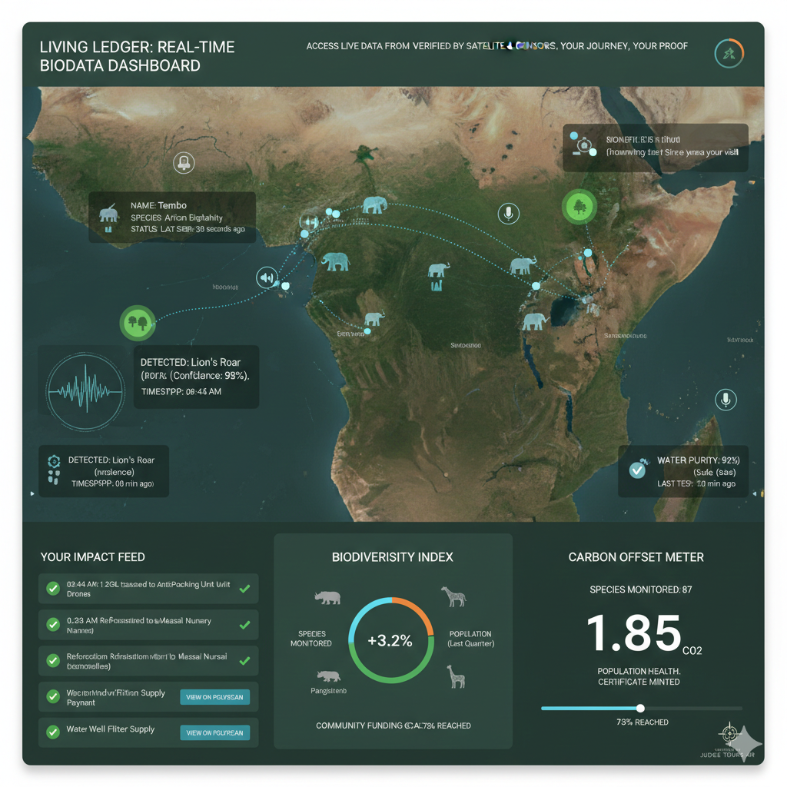

4. Governance & "The Traveler’s Vote"
Give the traveler a seat at the table.

DAO (Decentralized Autonomous Organization)

The Traveler’s Vote: Your Seat at the Table
Traditional tourism often decides where "charity" money goes behind closed doors. At Judge Tours, we believe that if you are the one funding the conservation, you should have a voice in its direction. This is made possible through our Impact DAO.

What is a DAO? (The Simple Version)
Think of a DAO as a community-led co-op without a central "boss."
- Decentralized: No single person at Judge Tours makes the final call on grant funding.
- Autonomous: Once the community votes, a "Smart Contract" automatically releases the funds it doesn't wait for a bank's approval.
- Organization: It’s a group of like-minded travelers (like you) working toward a shared goal: the flourishing of East Africa.

How Your Voting Power Works
When you join our Web3 Membership, your "Impact Token" acts as your ballot.
- Standard Members: Receive 1 vote per quarter.
- Elite Members: Receive weighted voting power and the ability to propose new projects for the community to consider.
The Quarterly Grant: You Decide the Impact
Every three months, Judge Tours pool a portion of all tour fees into the Stewardship Fund. We then present three verified local needs to our members. You aren't just a spectator; you are a decision-maker. This quarter, will your vote provide a solar-powered water well for a Maasai village, or will it fund a thermal-imaging drone to help rangers protect Rwanda’s last remaining silverbacks? The choice is yours.

The "Smart Contract" Guarantee
The beauty of the DAO is certainty. Because it is built on the blockchain, you can see the results of the vote and the subsequent transfer of funds in real-time. There is no "lost in administration." If the community votes for the drone, the funds go to the drone supplier instantly and transparently.

5. Verified Carbon-Negative Certification
The ultimate "Social License" for the modern traveler.
Modern travel shouldn’t just aim to "do no harm “it should actively heal. At Judge Tours, we don't just "offset" your emissions; we over-retire carbon credits in real-time. This ensures every journey is Carbon-Negative, removing 110% of the CO2 produced by your flights and local transport.

What is an "On-Chain" Certificate?
Traditional carbon offsetting is often opaque. By using the blockchain, we provide Proof of Retirement. When a carbon credit is "retired," it is taken off the market forever so no one else can claim it. Our Web3 system links your specific booking ID to a unique transaction on the ledger.

Sample On-Chain Certificate Details
When you click to view your certificate, you will see a personalized dashboard containing:
- Certificate ID: JT-2026-RW-8821 (Immutable & Unique)
- Emissions Calculated: $1.85\text{ tCO}_2\text{e}$ (Covers international flights + luxury safari transport)
- Carbon Retired: $2.05\text{ tCO}_2\text{e}$ (Verified high-quality "Blue Carbon" or Reforestation credits)
- Project Origin: Tanzania Ruaha Landscape Reforestation (Gold Standard Certified)
- Blockchain Hash: 0x7a2...4f9b A direct link to the Polygon or Ethereum explorer, proving the credits were burned for your trip specifically.

Value Proposition: Your Immutable Proof
Go beyond 'Carbon Neutral.' We use Web3 to retire high-quality carbon credits in real-time. This provides you with a personalized, tamper-proof certificate that proves your East Africa adventure removed more CO2 than it produced. Share it on LinkedIn, your personal site, or with your corporate responsibility team, it is the definitive digital proof of your positive global legacy.

Why Travelers Value This:
- Transparency: You can see exactly which reforestation or clean-water project received the funding.
- No Double-Counting: The blockchain ensures that the specific tonne of carbon you retired cannot be sold to anyone else.
- Audit-Ready: For business travelers or influencers, this provides the rigorous data needed to satisfy green-travel reporting requirements.

6. "Web3 Without the Headache" (FAQ)
Most travelers are afraid of losing a "seed phrase" or dealing with a "wallet."
- No Wallet Needed. You don’t need a "wallet" or cryptocurrency to start. New to Web3? No problem. We handle the technical side. Your impact record is tied to your email login and secured by the blockchain. You get security and transparency without needing to be a tech expert.

